EC2 Instance Creating steps:
=============================
->Create EC Instance by following below steps:
Note: You should have AWS account , should login and goto All services
Step-1
Goto All Services -> Select EC2 service
Click launched button
Step2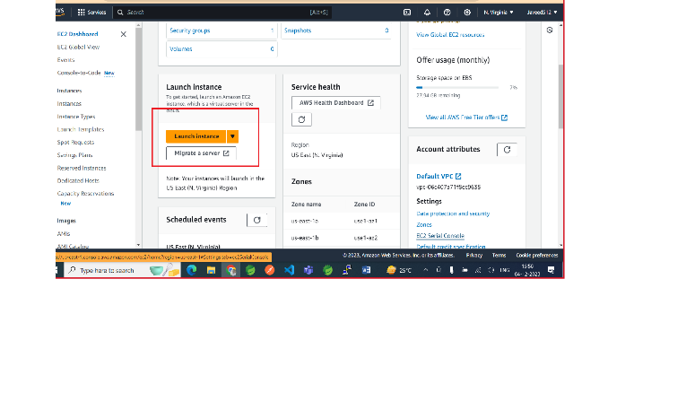
Enter Name and Tags
Name [springboot-aws-example]
Select O.S / Amazon Machine Image (AMI)
Select default eligible for free tier. Ex: Linux O.S / Linux AMI
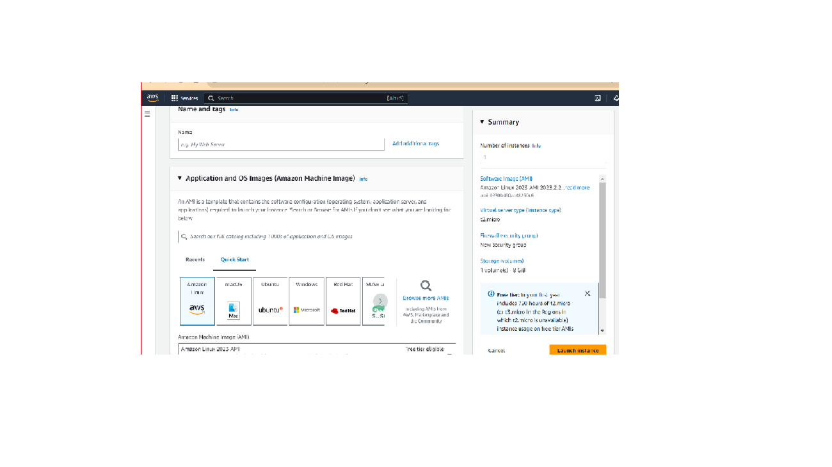
Step3
Select Instance Type default eligible for free tier
Step4
Create key pair (for login purpose)
Write any keypair name and generate key pair
Note: It will generate key-pair in .pem file format (private key)
Keypair name = springboot-aws
Generated File wil be : springboot-aws.pem

After key pair generate just select or keep default things and launch EC2 instance
By clicking launch button.

Remember if we want to connect from local O.S /Machine to EC2 Instance (AMI) we need putty software
Download and install putty in windows , which also intall puttyGen automatic

Now, open puttyGen and load pem file to generate ppk file
springboot-aws.pem springboot-aws-key.ppk

Now, open putty software and copy HostName from EC2 instance connect page.
Inside EC2 Instance details page we find some host name like below
ec2-100-24-49-87.compute-1.amazonaws.com
copy this into HostName in putty window

Then , open Data option inside putty window and write username from EC2 Instance
Ex: ec2-user is default username or we can write custom user name by clicking connect option under ec2 instance page.
SSH option and Goto Auth select credentials Browse private key file here and open it

Finally it will connect with EC2 Instance from local machine to AWS EC2 Instance / AMI

Once we connect to EC2 AMI from local machine we can install any thing like Java , Mysql , Angular etc.

https://springboot-aws-bucket.s3.amazonaws.com/springboot-0.0.1-SNAPSHOT.jar

